Group 7

**Client-Side App Rubric** <https://github.com/denisecase/pbl-lifeline-links>

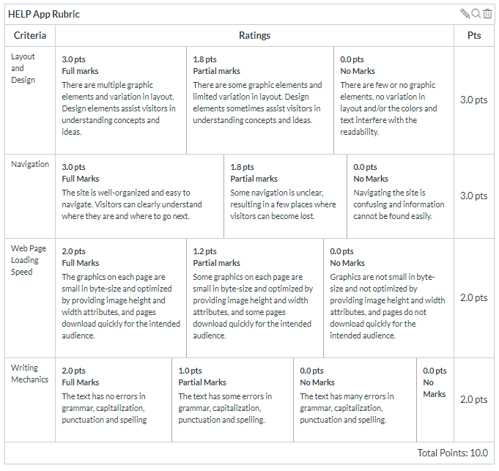

**Team reviewed:**

**Link to the web site:**

<https://kdibben.github.io/group-7-help-app/#pricing>

**Layout and Design**

Score: 1.8

Comments:

It was interesting to see the whole site spread out within one page.

* The photo of the old man can be a bit smaller, as it is taking up a lot of height.
* It’d be nice to see some color from the photo pulled and incorporated a bit more thought the site. It’s a bit too grey making the sections blend together.
* **About**
  + There needs to be a larger break between the the About section with the rest. The text is a bit cramped.
* **Program**
  + The images are a nice indicator for what you’re reading below. However the *Affordable Monthly Subscriber Fee* section is too long compared to the rest of the section.
  + If you can turn that section into a grid layout and then add a scroll for just that section.
  + Another option is to have the paragraphs act as a drop-down element from the image/header
* **History**
  + Add a double space or slight break between each bulleted item. They are hard to follow and can easily get mixed up.
* **Pricing**
  + Good layout. Try adding cell outlines to help follow. They don’t have to be super bold, but enough to tell if they are there.
* **Contact**
  + Good, but could be centered to look nicer.
  + No need for #, just say Home, Cell, Work

**Navigation**

Score: 3.0

Comments:

Clear and easy to follow. Though the photo in the top left corner isn’t needed as there is already a link for the home section.

The one thing I’d change is the color for when you hover. It’s hard to tell that they changed color. Maybe a green from the photo or even add an underline like the headings.

**Loading Speed:**

Score: 3

Comments:

Everything loaded quick and looks good.

**Writing Mechanics:**

Score: 3

Comments:

I didn’t find any errors. Maybe a bit more leading space?

**General remarks:**

Overall the design and layout is nice a clean. It’s easy to follow and looks professional. One thing I’d like to point out is this is a site targeted for older people, usually 60s or older. Consider this when choosing your font type and size.

* Font
  + Bigger font sizes are easier to read especially from a tablet or phone. Even on a laptop it’s hard to read.
  + Using the Sans-Serif font was a nice touch. It’s easier to read sans-serif from a screen that that of a serif. (i.e. sans-serif=“this font” serif=“this font”)
  + Maybe bold your headings for easier differentiation.
* Color
  + Again aside from the photo at the top of the page there is no color but the small blue under the headings.
  + Use colored bullet points, or transparent colored background. It will help hold interest.

**Review performed by:**

Group 2

**Date and time performed:**

November 3- 1:30 pm